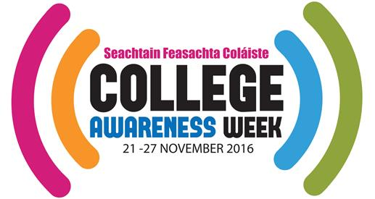
College Awareness Week Events Form 2016
Your event title: (ie Careers Fair) Event date: Event time: ie from X am/pm to Y am/pm / All day Event category (Put an x beside one): Company Tour Family Fun Day Further Education Event Library Event Guidance Counsellor School based event Talk/Lecture Workshop Other
Venue Name:
Venue Address:
City/Town: County: Postcode: Province:

Who are you? Put an ‘x’ beside one:
School teacher Guidance Counsellor Other event organiser

Audience Category: Put an ‘x’ beside one:
All Primary level Primary & Second Level Second Level: Junior Cycle Second Level: Senior Cycle Second Level: All Third Level Families General Public

Admission Details: Put an ‘x’ beside one: `
Free Free but booking essential Invitation only Entry Fee

Type of organization: Put an ‘x’ beside one:
Primary school Secondary school Third level institution Company Library Non-profit/voluntary Outreach/education Public sector/government City/county council Other

Event organiser contact name:
Event organiser email address:
Event organiser phone number:
Merchandise delivery contact name and address (if different from above):

Merchandise delivery contact phone number (if different from above):

Email your completed form to info@collegeaware.ie

