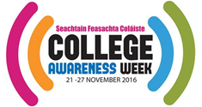
You make the Difference!
By taking a few minutes to fill in this evaluation form, you provide us with valuable feedback and the sharing of ideas that will help us make College Awareness Week 2017 even better…
College Awareness Week 2016 – Post-Event Evaluation

Thank you for taking 10-15 minutes out of your time to complete this evaluation.

- Describe the event (s) which took place in your school/ organisation during College Awareness Week.

- Who was involved in College Awareness Week in your school/ organisation?
Please tick all that apply:

Management
Subject teachers
Guidance Counsellor(s)
Former students / Alumni
Parents
Local community organisations
Colleges / Universities
Libraries
Businesses
Other (please explain)

- In your opinion was College Awareness Week a whole-school/ whole-organisation event?

- Yes

- No

- Not sure

- How many participants were involved in your events/ activities?

- In your opinion, what were the highlights from the week?

- In your opinion, what were the challenges?

- Would you like your school/organisation to be involved in College Awareness Week next year?
- Yes name of contact & email for future communication:
- No
- Maybe

- How did you find out about College Awareness Week?

- Did you find the resources available on www.collegeaware.ie useful in planning/ hosting an event?

a) Yes, very much b) Somewhat c) Uncertain d) Not really e) No, not at all

Please explain which resources you used and provide some ideas of additional resources you require:

- Did you visit/use the social media platforms (Twitter, Facebook, Instagram, LinkedIn Group) for College Awareness Week?

Please tick or mark and X for all that apply:

Facebook
Twitter
Instagram
LinkedIn group
None
Which channel(s) did you use the most – and why
Please supply your twitter username so we can follow you.

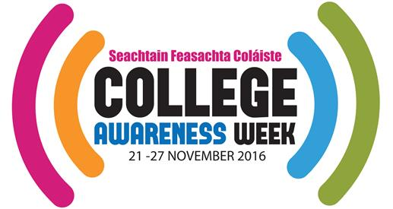
- Which CAW merchandise best suited your event? Please explain what works, what didn’t work, what you would recommend.)

Please tick all that apply:
Pens
Adult t-shirts
Kids t-shirts (what age groups?)
Badges
Stickers
Small selfie frames
Posters
Large banner
Suggestions or other ideas

What quantities would you require for your event?

- Do you have suggestions for how College Awareness Week can be improved?

Thank you for sharing your time and ideas! Please return by post or email:

Post: Kathleen O’Toole-Brennan, c/o Trinity Access Programmes, Goldsmith Hall, Trinity College, Dublin 2

Email: kotoole@tcd.ie Questions? Give us a call on Ph: 01 896-3590

www.facebook.com/collegeaware
@CollegeAware
www.instagram.com/collegeaware

